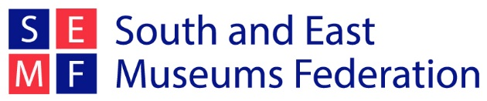

The South and East Museums Federation is unique among UK Museum Federations in organising an annual study trip that gives members a rare opportunity to visit behind the scenes and meet members of staff from museums across Europe and beyond.

Study trips are organised voluntarily by SEMFed members. It is a great opportunity to learn from fellow professionals across the world and socialise with fellow SEMFed members over dinner & drinks. (Members are welcome to bring a partner or friend with them).
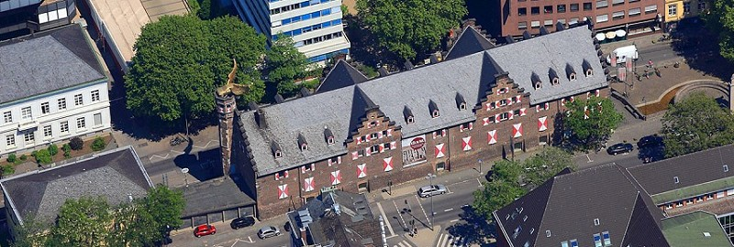

Cologne 2018

The 2018 SEMFed Study Trip will be to Cologne, Germany and will take place from 31 January to 3 February.

Places on the trip are limited to 30 to allow for a good ‘behind the scenes’ experience. Exact details of visits included on the trip are still being confirmed but will include visits to a range of museums & galleries, including behind-the-scenes tours, Q & A’s and added value experiences.

The trip is open to all current SEMFed members and their partners. (Membership costs £10 for the year) http://www.semfed.org.uk/membership/

Booking deadlines:
- Booking will open on Tuesday 31st October and close on Thursday 30th November, or once the trip is full.
- Deadline to apply for the Martin Howe bursary is Wednesday 18th October.

Martin Howe bursary

Each year, SEMFed offers a travel bursary in honour of Martin Howe, an ex-President of the Federation who was involved in the organisation for many years. Martin Howe was Curator at Peterborough Museum from the 1980s to the early 1990s, when he became ill and died at a young age. Together with Martin’s widow, the Federation decided a travel bursary would be a small but fitting way to commemorate his life.

This year SEMFed will be visiting Cologne on our study trip 31st January to 3rd February 2018. Further information about the trip will be circulated by the middle of September.

The £200 bursary helps to cover travel and accommodation costs of the study trip and is open to all SEMFed members who have not been on the Study Trip before.

The recipient must write a report on the trip which is circulated to all members and will feature on the website and newsletters. The bursary will be sent on receipt of the finished report.

To apply for the bursary:
- You need to be a member of the South and East Museums Federation
- Send a letter of application (maximum of 500 words) to us telling us about yourself, your current role in museums, why you want to go on the trip and how the bursary will enable you to come.
- Please email this letter to ackroyd@norfolk.gov.uk by 18th October 2017

Follow this link to download this information
Follow this link to our Study Trip page

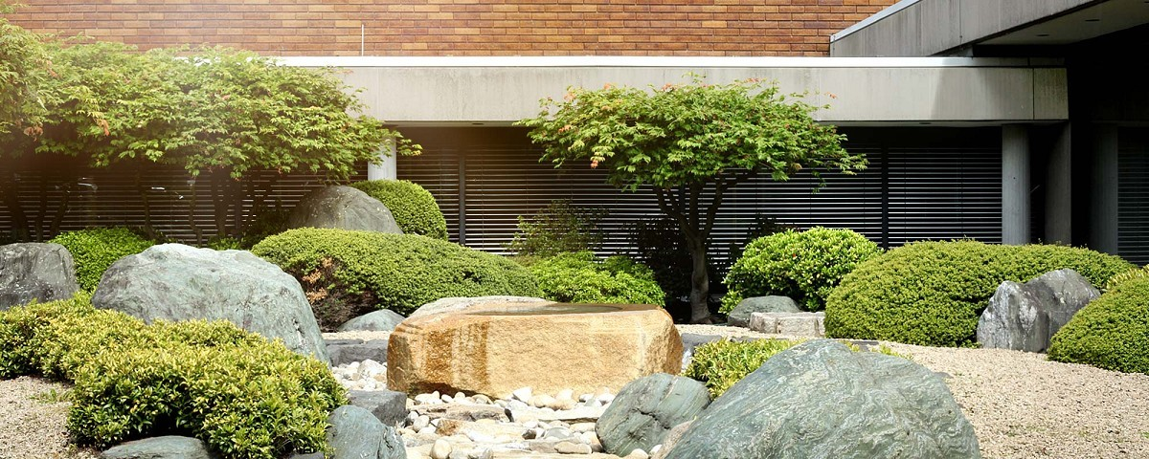

Cologne
As well as its world famous Cathedral, Cologne has dozens of museums including those devoted to perfume, chocolate and sport. So far we have confirmed two visits:
Cologne City museum from 10am-11.30am on the 1st of February
The Museum of Ostasiatische Kunst (East Asian art) from 11am on the 2nd of February
There will also be visits arranged in the afternoons – we will keep you posted as museums respond! As usual we will have tours of the museums (in English) and some behind-the-scenes access. If you can, please bring some small souvenirs from your museum so that we can create goody bags to thank our hosts.

Potential Itinerary
Wednesday 31st January
Arrival, check in and an evening meal with the group at a local restaurant

Thursday 1st February
Two formal museum visits, starting at the Cologne City Museum

Friday 2nd February
Two formal museum visits, starting at the Museum of East Asian Art

Saturday 3rd February
Free day to explore or depart.

The trip is entirely flexible, so you may choose to leave early or join the group later than the first day. However, we need a decent number of us to attend the arranged visits so please make every effort to attend these.

There are plenty of other museums in Cologne – there is a good introduction to them at https://www.cologne-tourism.com/attractions-culture/museums.html

Travel
There are many options for traveling to Cologne from the UK and it is up to you which method you book. There will be a group evening meal on Wednesday 25th which you may wish to arrive in time for.

There are direct flights from Stansted (around £40-£60) and Heathrow (£80-£100) to Cologne/Bonn Airport (CGN). There is a station on the lower floor of the airport with S-Bahn trains every 20 minutes to the city centre (20-30 minute journey).

Eurostar also offer services to Cologne, with tickets around £50 one-way booked two weeks in advance.
Accommodation
The best looking hotel for our needs seems to be the
Hotel Lyskirchen
Built in 1922, but recently modernised, the hotel is about 20 minutes walk from the City Centre and has the luxury of a pool! (but is the same pricing band as other similar ones without a pool.)
Cost – with the pound/euro rates changing all accommodation is looking more expensive this year. Booking sites Trivago and Booking.com and the hotel’s own website currently shows a double/twin room for about £84 per night without breakfast. This can be added on for 19 euros.
Once you have reserved your place on the trip it is up to you to book your accommodation. This way you can select the options which best suit you. If you would like to split the cost of a room by sharing with someone else attending the trip please indicate this on your booking form and we will do our best to arrange a room share.
If you would prefer you are welcome to book alternative accommodation to our suggestion, and then join the rest of the group for the arranged visits and social options.
Booking Information
- Booking will open on Tuesday 31st October and close on Thursday 30th November, or once the trip is full.

Places will be limited to 30 and on a first come, first served basis. Please book your place by completing the booking form and returning to Alison on arecamuk@yahoo.co.uk
You will receive a confirmation email once you are booked onto the trip. We then ask you to book your accommodation and travel options yourself.
If you are interested in applying for the Martin Howe bursary, the deadline to apply is 18th October 2017. Applications should be sent to sally.ackroyd@norfolk.gov.uk

Thank you - We hope to see you there!

Sally Ackroyd and Alison Giles
(SEMFed committee members and organisers of the Cologne study trip)

