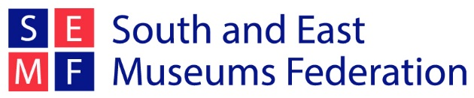

Martin Howe bursary

Each year, SEMFed offers a travel bursary in honour of Martin Howe, an ex-President of the Federation who was involved in the organisation for many years. Martin Howe was Curator at Peterborough Museum from the 1980s to the early 1990s, when he became ill and died at a young age. Together with Martin’s widow, the Federation decided a travel bursary would be a small but fitting way to commemorate his life.

This year SEMFed will be visiting Wales on our study trip 22nd January – 25th January 2020. A further information pack about the trip can be downloaded from the SEMFed website: www.semfed.org.uk/study-trip

Two bursaries are available for the 2020 study trip. The £200 bursary helps to cover travel and accommodation costs of the study trip and is open to all SEMFed members who have not been on the Study Trip before.

The recipient must write a report on the trip which is circulated to all members and will feature on the website and newsletters. The bursary will be sent on receipt of the finished report.

To apply for the bursary:
- You need to be a member of the South and East Museums Federation
- Send a letter of application (maximum of 500 words) to us telling us about yourself, your current role in museums, and why you want to go on the trip.
- Please email this letter to admin@semfed.org.uk by 5pm Friday 11th October 2019.
- Applicants will be notified on whether they have been successful no later than Thursday 17th October.

For more information about the bursary see the SEMFed website or contact the SEMFed Vice President Lauren Ephithite on admin@semfed.org.uk

