The South and East Museums Federation is unique among UK Museum Federations in organising an annual study trip that gives members a rare opportunity to visit behind the scenes and meet members of staff from museums across Europe and beyond.

Study trips are organised voluntarily by SEMFed members. It is a great opportunity to learn from fellow professionals across the world and socialise with fellow SEMFed members over dinner & drinks, (members are welcome to bring a partner or friend with them).

Copenhagen Study Trip 2019
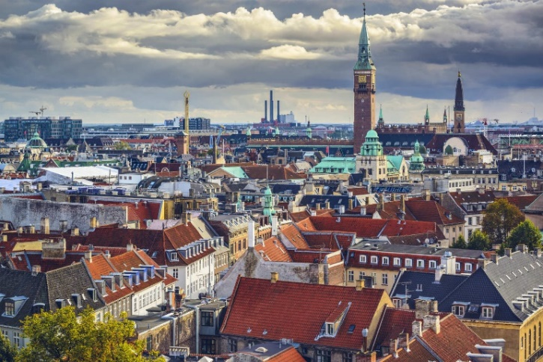
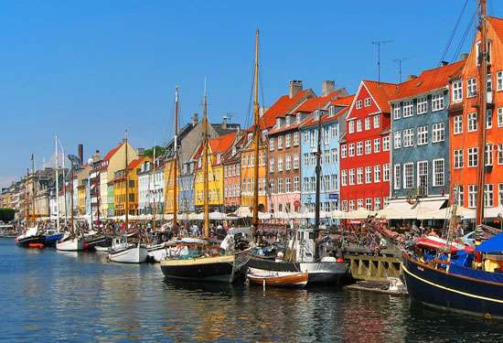

The 2019 SEMFed Study Trip will be to Copenhagen, Denmark and will take place on 30th January - 2nd February.

Places on the trip are limited to 25 to allow for a good ‘behind the scenes’ experience. Exact details of visits included on the trip are still being confirmed but will include visits to a range of museums & galleries, including behind-the-scenes tours, Q&A’s and added value experiences.

The trip is open to all current SEMFed members, (membership costs £10 for the year). Find out more about becoming a SEMFED member at semfed.org.uk/membership/

Booking deadlines:

- Booking will open on Monday 8th October and close on Friday 2nd November, or once the trip is full.

- The deadline to apply for the Martin Howe bursary is 5pm on Friday 28th September.

Martin Howe bursary

Each year, SEMFed offers a travel bursary in honour of Martin Howe, an ex-President of the Federation who was involved in the organisation for many years. Martin Howe was Curator at Peterborough Museum from the 1980s to the early 1990s, when he became ill and died at a young age. Together with Martin’s widow, the Federation decided a travel bursary would be a small but fitting way to commemorate his life.

Two bursaries are available for the 2019 study trip. The £200 bursary helps to cover travel and accommodation costs of the study trip and is open to all SEMFed members who have not been on the Study Trip before.

The recipient must write a report on the trip which is circulated to all members and will feature on the website and newsletters. The bursary will be sent on receipt of the finished report.

To apply for the bursary:

- You need to be a member of the South and East Museums Federation
- Send a letter of application (maximum of 500 words) to us telling us about yourself, your current role in museums, and why you want to go on the trip.
- Please email this letter to e.shepperson@welhat.gov.uk by 28th September 2018 by 5pm.
- Applicants will be notified on whether they have been successful no later than Friday 5th October.

For more information about the bursary see the SEMFed website or contact the SEMFed Vice President Emily Shepperson on e.shepperson@welhat.gov.uk or
01707 357850.

Copenhagen
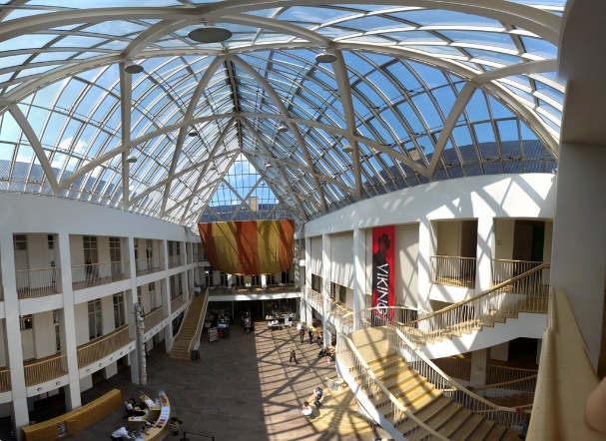
Copenhagen, capital of Denmark and is the cultural, economic and governmental centre of the country, with links to nearby Sweden, and is the home of great Danish design and history, beginning life as a Viking village.
Copenhagen has over 50 museums and art galleries ranging from Viking beginnings to Royal Palaces. Many are in the city centre and very short walks from each other, including the National Museum of Denmark (Nationalmuseet). Other museums and galleries include Danish Museum, Design Museum, Elsinore City Museum, Danish Police Museum, Kunstforeningen, Medical Museion, Danish National Gallery, Museum of Music, David Collection, National Museum of Photography, Natural History Museum of Denmark, Open Air Museum, Post & Tele Museum, Worker’s Museum, Resistance Museum, Royal Danish Naval Museum (to name just a few!)
A Copenhagen card available which allows free admission to 86 attractions and free transport in the city. The card is available in a 24,48, 72 or 120 hour card and may be worth considering if you want to explore more on the Saturday or extend the visit. https://copenhagencard.com/

Potential Itinerary
- Wednesday 30th January
Arrival, check in and an evening meal with the group at a local restaurant

- Thursday 31st January
Two formal visits – to be arranged

- Friday 1st February
Two formal visits – to be arranged, evening social activity

- Saturday 2nd February
Free day to explore or depart.

The trip is entirely flexible, so you may choose to leave early or join the group later than the first day. However, we need a decent number to attend the arranged visits so please make every effort to attend these.

There are lots of other things to see and do in Copenhagen – take your pick of 50 museums, explore the streets and port, pop across to Sweden or go shopping and peruse a market. Check out https://www.visitcopenhagen.com/copenhagen-tourist for more ideas.

Travel
There are many options for traveling to Copenhagen from the UK and it is up to you which method you book. There will be a group evening meal on Wednesday 30th which you may wish to arrive in time for.

Travel suggestions:
- Stansted to Copenhagen with Ryan Air: approximately £78 return
- Luton to Copenhagen with Ryan Air: approx. £65 return
- Heathrow to Copenhagen British Airways: Approx. £69 return
- Trains to Copenhagen from London from £90 (14h: 22mins usually 3 changes at Brussels, Cologne and Hamburg)

It takes less than 15 minutes to go from Copenhagen Airport to the city centre by train or metro. Both metro and train run from Terminal 3. You will need a ticket for three zones, which costs £4.50. Travel to Copenhagen Central Station is via train or Bus 5A. Taxis are also available outside Terminal 1 and 3 and will arrive in downtown Copenhagen in about 20 minutes depending on traffic.

The Copenhagen Card gives you unlimited public transportation in the entire Capital Region of Denmark incl. public transportation to/from Copenhagen Airport. https://copenhagencard.com/

You could also look into getting a CityPass for unlimited travel on buses, trains and the metro in Copenhagen in zones 1-4, from the moment you arrive in Copenhagen. https://dinoffentligetransport.dk/citypass

Accommodation
We are suggesting the Cabinn City Hotel for accommodation during the study trip. This budget hotel is within 5 minutes’ walk of Copenhagen Central Station and Tivoli Gardens. It offers free Wi-Fi, rooms with private bathrooms and a popular breakfast buffet. There is also an area for us to congregate before going to your study visits.
https://www.cabinn.com/en/hotel/cabinn-city-hotel
This hotel is a short walk from the Central Station in Copenhagen which is a 20 min train ride from the airport. The hotel has a range of rooms including single rooms and receives good reviews on TripAdvisor.
The price for three nights for a double room is currently approximately £250 (£300 with breakfast buffet).

Once you have reserved your place on the trip it is up to you to book your accommodation. This way you can select the options which best suit you. If you would like to split the cost of a room by sharing with someone else attending the trip please indicate this on your booking form and we will do our best to arrange a room share. IF you have organised to share a room then please let us know with who on your booking form.

If you would prefer you are welcome to book alternative accommodation to our suggestion, and then join the rest of the group for the arranged visits and social options.

Booking Information
Booking will open on Monday 8th October, and close on Friday 2nd November or once the trip is full.
Places will be limited to 25 and on a first come, first served basis. Please book your place by completing the booking form and returning to Emily on e.shepperson@welhat.gov.uk
You will receive a confirmation email once you are booked onto the trip. We then ask you to book you accommodation and travel options yourself.
If you are interested in applying for the Martin Howe bursary, the deadline to apply is Friday 28th September 2018.
Applications should be sent to e.shepperson@welhat.gov.uk

Thank you - We hope to see you there!
Tabitha Runacres and Jenna Ingamells
(SEMFed Committee members and organisers of the Copenhagen study trip)

